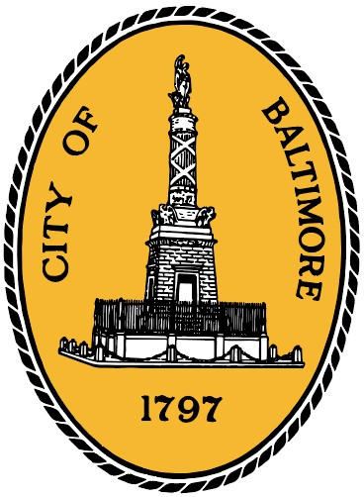Nick J. Mosby, President
Baltimore City Council

100 N. Holliday Street. Room 400 Baltimore, Maryland 21202 (410) 396-4804 - Fax: (410) 539-0647

MEMORANDUM

To: Honorable Brandon M. Scott, Honorable Bill Henry, Acting City Solicitor Ebony
Thompson, Director Jason Mitchell
From: Council President Nick J. Mosby Date: Wednesday, June 28, 2023
Re: Board of Estimates Agenda Items for Wednesday, June 28, 2023, at 9:00 am

The items on the Board of Estimates Agenda for Wednesday, June 28, 2023, are to be assigned as follows:

ROUTINE:

P 2 SB-23-12117 - Mayoralty - Professional Services/Operating - Memorandum of
Understanding (MOU)
P 3 SB-23-11915 - M-R Office of Neighborhood Safety and Engagement - Grant
Expenditure - Grant Agreement
P 4 SB-23-12059 - M-R Office of Neighborhood Safety and Engagement - Grant
Expenditure - Grant Agreement
P 5 SB-23-12200 - M-R Office of Neighborhood Safety and Engagement - Grant
Expenditure - Grant Agreement
P 6-7 SB-23-12340 - Procurement - Procurement via DOF - Consulting/Professional
Services Agreement
P 8 SB-23-12366 - Procurement - Procurement via DOF - Cooperative Contract
P 9 SB-23-12361 - Procurement - Procurement via DOF - Equipment
Maintenance/Service Contract
P 10-11 SB-23-12360 - Procurement - Procurement via DOF - Goods & Services
Contract
P 12 SB-23-12359 - Procurement - Procurement via DOF - Goods & Services
Contract
P 13-14 SB-23-12365 - Procurement - Procurement via DOF - Technology
License/Service/Software Agreement
P 15 SB-23-12384 - Procurement - Procurement via DOF - Technology
License/Service/Software Agreement

